**GURU GOBIND SINGH INDRAPRASTHA UNIVERSITY**

**PROJECT TITLE: Rainfall Prediction**

**MINOR PROJECT**

**ICT-497**

**Submitted in partial fulfilment of the requirements**

**for the award of the degree of**

**Bachelor of Technology**

**in**

**Computer Science Engineering**

**at**

**UNIVERSITY SCHOOL OF INFORMATION, COMMUNICATION AND TECHNOLOGY**

**Supervisor: Dr. Jyotsana Yadav Submitted By: Bharat Sahay**

**Enrollment No: 01816403221**

**Programme: B.Tech. CSE 7th Sem**

**Table of Contents**

1. Declaration
2. Certificate of Originality
3. Introduction
4. Objectives
5. Technology Used
6. Work Done
7. Planned Features
8. References

**DECLARATION**

I, **Bharat Sahay** , a student of Bachelor of Technology in Computer Science & Engineering at the **University School of Information, Communication & Technology (USICT), Guru Gobind Singh Indraprastha University, New Delhi**, hereby declare that the work presented in this minor project report titled **"Lung Cancer Prediction using Machine Learning"** is an original and authentic effort undertaken by me under the technical guidance of **Dr. Jyotsna Yadav**.

I affirm that due acknowledgment has been made wherever necessary, and the information used in this project has been properly cited and referenced. The progress report has been checked by Turnitin Plagiarism Detection software at GGSIPU. The work is free from any sort of plagiarism, fabrication, falsification, or copyright issues, and the similarity of the contents identified is as per UGC norms.

I declare that the work in this project has not been submitted in full or in part for any diploma or degree course of this University or any other University/Institute to the best of my knowledge and belief. I shall be solely responsible for any copyright infringement or plagiarism, if any, in the said project or any dispute arising out of my work. My supervisor or anyone else shall not be held responsible for any full or partial violation of copyright/intellectual property rights/plagiarism issues. All the inputs and suggestions by the supervisor and SRC have been incorporated into the project report.

Bharat Sahay  
B.Tech CSE Student

(Enrollment No: 01816403221)  
University School of Information, Communication & Technology,  
Guru Gobind Singh Indraprastha University,  
Sector-16C, Dwarka, New Delhi, India-110078

Date-25/10/2024

**UNIVERSITY SCHOOL OF INFORMATION, COMMUNICATION AND TECHNOLOGY**

**GURU GOBIND SINGH INDRAPRASTHA UNIVERSITY**



**Certificate of Originality**

This is to certify that the work embodied in this project report titled **"Lung Cancer Detection using Machine Learning"** is an original piece of work carried out by **Bharat Sahay**, a student of Bachelor of Technology in Computer Science & Engineering at the **University School of Information, Communication & Technology (USICT), Guru Gobind Singh Indraprastha University**. This project has been completed under the supervision of **Dr. Jyotsna Yadav**.

The work has not been submitted, in part or in full, for any other degree or diploma at this or any other university, based on the declaration of the candidate.

It is certified that the work being submitted for this project report is free from any form of falsification, fabrication of results, data, claims, copyrights, and plagiarism, to the best of my knowledge and belief.

**Dr. Jyotsna Yadav** **Bharat Sahay**Supervisor B.Tech CSE Student  
University School of Information, Communication & Technology 01816403221  
Guru Gobind Singh Indraprastha University,  
New Delhi

Date-25/10/2024

**Abstract**

This project focuses on developing a machine learning model for **Lung Cancer Prediction** using the **Survey of 234,580 Cases of lung cancer done by American Cancer Society (ACS) in 2015**.

Lung cancer remains one of **the leading causes of death** worldwide, primarily due to late-stage diagnosis. Early detection is crucial for improving survival rates, and machine learning (ML) offers a promising approach to automate and enhance the diagnostic process. This study explores the **application of machine learning techniques** for the detection of lung cancer using patient data, including clinical attributes and imaging features. **A variety of machine learning algorithms, including Random Forest, Gradient Boosting,** and Support Vector Machines, were implemented to build predictive models based on a dataset that includes both categorical and numerical features. The models were evaluated using common performance metrics such **as accuracy, precision, recall, F1-score, and ROC-AUC.** To address the challenge of class imbalance in the dataset, techniques such as **SMOTE (Synthetic Minority Over-sampling Technique)** were applied to enhance the classifier's performance.

The results indicate that **the Random Forest model achieved an accuracy of 0.84**, with potential improvements through fine-tuning and ensemble methods. This study demonstrates the potential of machine learning to assist healthcare professionals in early and accurate lung cancer diagnosis, thereby contributing to better patient outcomes and personalized treatment strategies. The model can be further improved through the inclusion of additional clinical and imaging data, as well as through advanced deep learning techniques.

The project is implemented using a variety of tools and technologies, including **Python**, **Pandas**, **NumPy**, **Scikit-learn**, and **Matplotlib**, to ensure efficient data preprocessing, modeling, and visualization. Key steps include data preprocessing, exploratory data analysis (EDA), model selection, and performance evaluation. Several machine learning algorithms, such as **Linear Regression**, **Random Forest**, and **Neural Networks**, are applied and evaluated based on performance metrics like **Mean Squared Error (MSE)** and **R-squared**.

**Introduction**

**Lung cancer is one of the most prevalent and deadly types of cancer worldwide**, accounting for a significant number of cancer-related deaths each year. It is often diagnosed at an advanced stage, when the chances of successful treatment are considerably lower. As a result, improving early detection is essential for enhancing survival rates and enabling more effective treatment strategies.

**Recent advancements in** healthcare technologies, particularly in the field of data science and **machine learning (ML)**, have shown great promise in addressing this challenge. Machine learning, a subset of artificial intelligence (AI), enables computers to learn patterns from data and make predictions without explicit programming

**This study focuses on** utilizing machine learning techniques for the **detection of lung cancer**. The goal is to create predictive models that can accurately classify whether a patient is at risk of having lung cancer based on a set of input features such as demographic information, lifestyle factors, medical history, and symptom observations. To ensure robust and reliable results, a variety of classification algorithms, including **Random Forest (RF)**, **Gradient Boosting (GBM)**, and **Logistic Regression (LR)**, are explored and compared.

One of the major challenges in lung cancer prediction is the class imbalance problem, where the number of healthy patients significantly outweighs the number of cancer-positive cases. To address this, advanced techniques such as **Synthetic Minority Over-sampling Technique (SMOTE)** and **undersampling** are employed to balance the dataset and improve the model’s ability to detect lung cancer. Additionally, model optimization techniques like **hyperparameter tuning** and **cross-validation** are used to enhance the accuracy and generalization of the classifiers.

Ultimately, this study contributes to the broader effort of improving cancer detection through AI and aims to provide insights into the future potential of machine learning in the medical field.

**Technology Used**

The **Lung Cancer Prediction using Machine Learning** project employs a range of modern tools and technologies to build an efficient and accurate machine learning model for cancer prediction. The project is developed using **Python** due to its extensive library support and ease of use in data processing and model development. The following technologies and libraries were utilized:

1. **Pandas**: This powerful data manipulation library is used to handle and preprocess the dataset. Pandas enables efficient cleaning, normalization, and transformation of the rainfall data, making it ready for modeling.
2. **NumPy**: NumPy provides support for high-performance numerical computations. It is used in this project for efficient handling of large datasets and performing mathematical operations, which are crucial in the model training process.
3. **Scikit-learn**: Scikit-learn is a machine learning library that simplifies the implementation of various algorithms. In this project, models such as **Linear Regression**, **Random Forest**, and **Neural Networks** are implemented using Scikit-learn. It also offers tools for model evaluation through metrics like **Mean Squared Error (MSE)** and **R-squared**.
4. **Matplotlib**: For data visualization, Matplotlib is used to generate insightful graphs and heatmaps. These visualizations help compare predicted and actual **cancer result** values, providing clear insights into model performance and future trends.
5. **Seaborn**: In addition to Matplotlib, Seaborn is employed for advanced visualization tasks, such as generating correlation matrices and detailed heatmaps, making exploratory data analysis (EDA) more intuitive.
6. **Jupyter Notebook**: This interactive environment is used for the development and execution of the project code. It allows for easy iteration during the model development process, enabling real-time visualization of results and facilitating rapid prototyping.

By integrating these technologies, the project ensures a robust and scalable solution for lung cancer prediction , making the most of advanced machine learning techniques and effective data handling practices. The combination of these tools enables the creation of an accurate model that can assist in detecting lung cancer probability in early stage .

**Work Done**

The development of the **Lung Cancer Detection using Machine Learning** project has primarily involved data preprocessing, exploratory data analysis, and model selection. Below is a summary of the work completed thus far:

**1. Data Preprocessing:**

* Cleaned the dataset by handling missing values to ensure the data was complete and reliable for model training.
* Normalized the dataset to standardize the range of rainfall values, making it suitable for machine learning algorithms.
* Split the data into training and testing sets for accurate model evaluation.

**2. Exploratory Data Analysis (EDA):**

* Conducted an in-depth analysis of the historical rainfall data to identify patterns, trends, and seasonality.
* Visualized geographical distribution of rainfall using heatmaps and identified correlations between rainfall and different regions of India.
* Summarized rainfall trends over the years to understand the data better before applying machine learning models.

**3. Model Development:**

* Implemented several machine learning algorithms, including **Random Forest, Gradient Boosting,** **XGBoost , Naive Bayes Classifiers** to predict future rainfall based on the historical dataset.
* Trained each model on the processed data, comparing performance across various algorithms.
* Focused on tuning hyperparameters to enhance model accuracy.

**4. Model Evaluation:**

* Evaluated the performance of the models using metrics such as **Evaluation Metrix Mean Squared Error (MSE) and R-squared (R²)** to determine their predictive power.
* Visualized the predicted versus actual rainfall to gauge the effectiveness of the models and to pinpoint areas for improvement.

This work has established a strong foundation for further model refinement and real-time Cancer Prediction , ensuring the project is on track for successful completion.

**Dataset Description:**

**1.** Dataset link **=** <https://www.kaggle.com/datasets/akashnath29/lung-cancer-dataset>

**2.** Detailed Patient Profiles for Lung Cancer Risk Assessment and Analysis

**3.** This dataset is an invaluable asset in the realm of Health Care, providing a structured foundation for the development of cancer detection models. This dataset exemplifies **the variety of symptoms of Lung Cancer**. Each category within the dataset—**'GENDER', 'AGE', 'SMOKING', 'YELLOW_FINGERS', 'ANXIETY', 'PEER_PRESSURE', 'CHRONIC_DISEASE', 'FATIGUE', 'ALLERGY', 'WHEEZING', 'ALCOHOL_CONSUMING', 'COUGHING', 'SHORTNESS_OF_BREATH', 'SWALLOWING_DIFFICULTY', 'CHEST_PAIN'—** • For some of the subdivisions data is from 1950 to 2015.

**Dataset Composition**

The Lung Cancer Dataset includes a diverse array of symptoms essential for comprehensive analysis and model development. The primary categories of data are as follows:

**1. Patient Demographics**

Age: Provides the age at diagnosis, enabling analysis of age-related incidence and outcomes.  
Gender: Includes information on patient gender, facilitating gender-based studies.  
Smoking Status: Categorized as current smoker, former smoker, or non-smoker, this data is critical for evaluating the impact of smoking on lung cancer risk and progression.

**2. Medical History**

Comorbidities: Details additional health issues such as chronic obstructive pulmonary disease (COPD), which are relevant for treatment planning and prognosis.

**3. Clinical Data**

Vital Signs: Records of blood pressure, heart rate, respiratory rate, and other vital signs at diagnosis and during treatment.





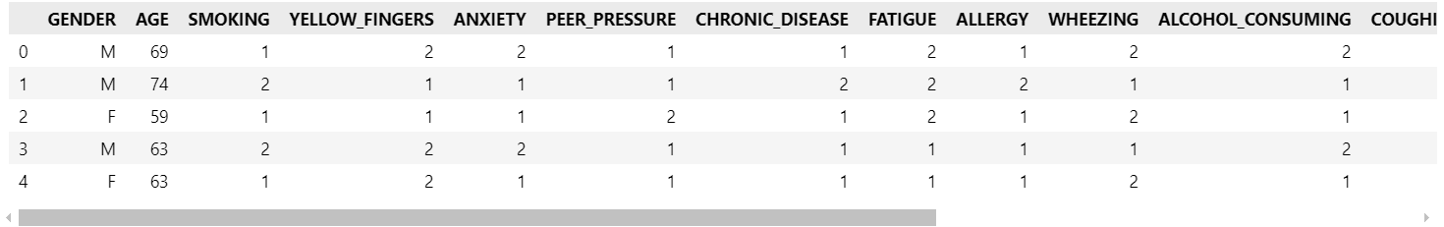

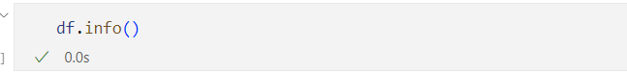

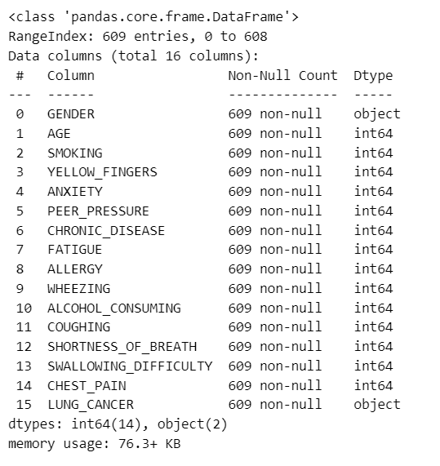

**Preprocessing Data : Hot Labeling**

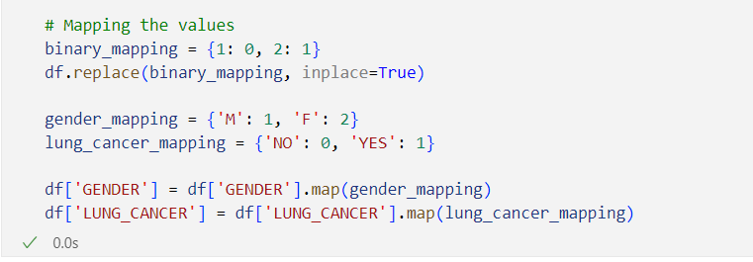

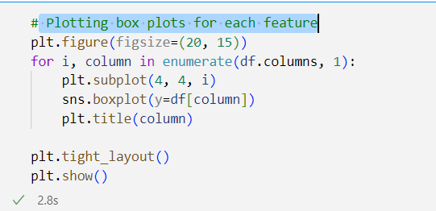**Plotting box plots for each feature :**

• Above histograms show the distribution of rainfall over months.

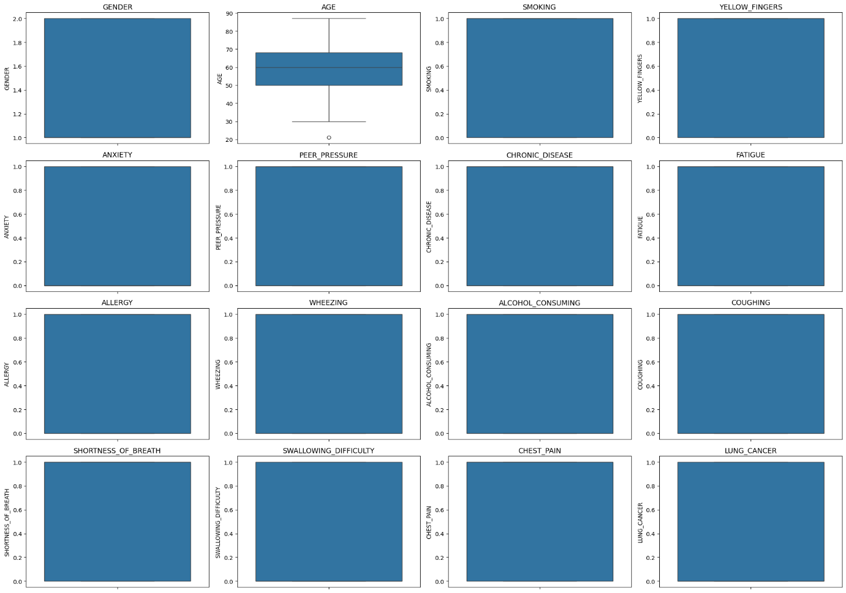

**Preprocessing Data : Mapping coded values**

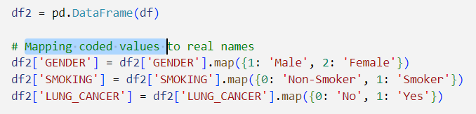

**Box Plot : Age Distribution by Smoking Status**

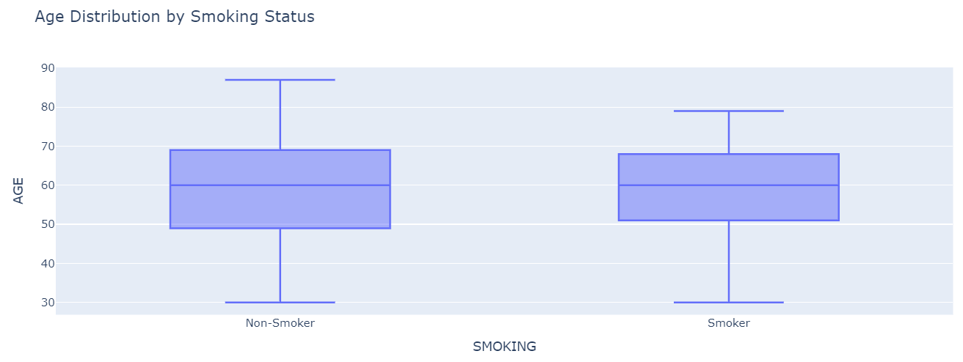

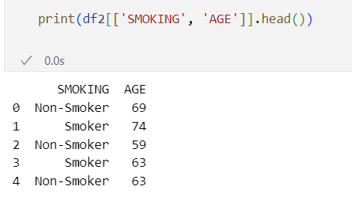

**Pie Chart : Lung Cancer Distribution**

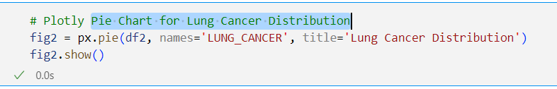

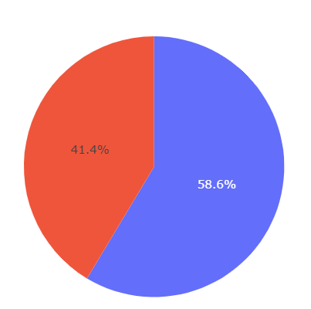

**The Correlation Matrix :**

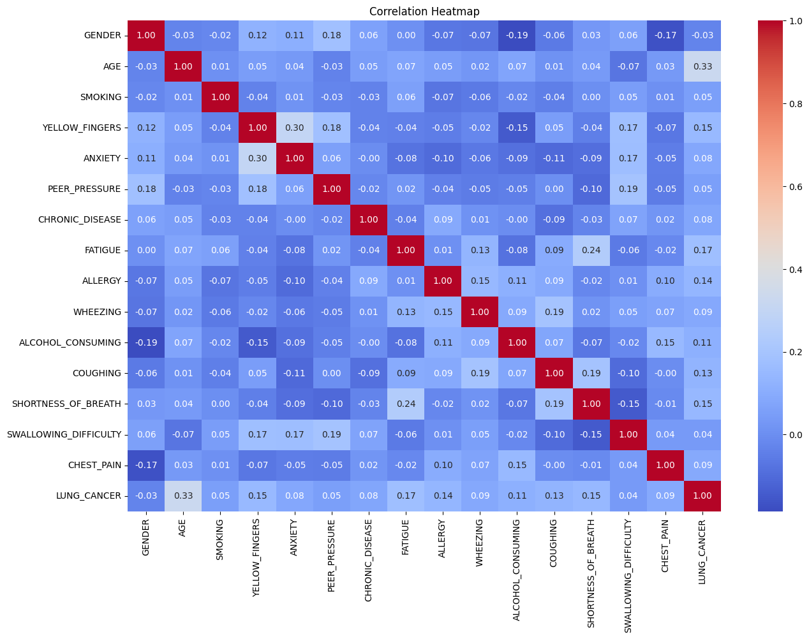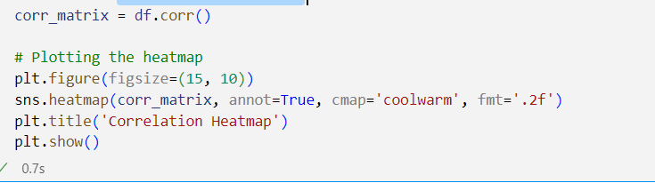



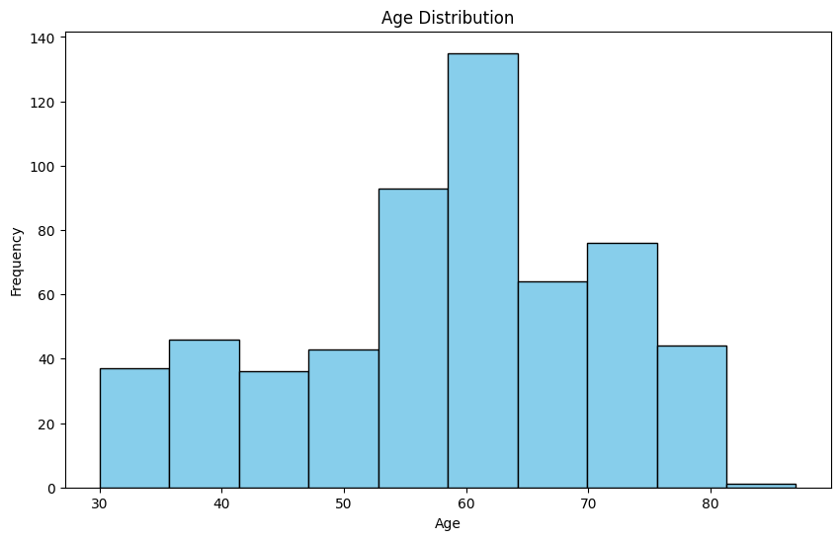**Histogram : Age**



• Heat Map shows the co-relation(dependency) between the amounts of rainfall over months.

• From above it is clear that if amount of rainfall is high in the months of july, august, september then the amount of rainfall will be high annually.

**Bar Plot: Smoking vs. Lung Cancer**

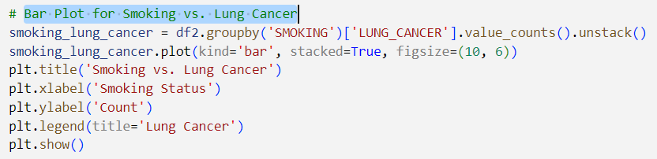 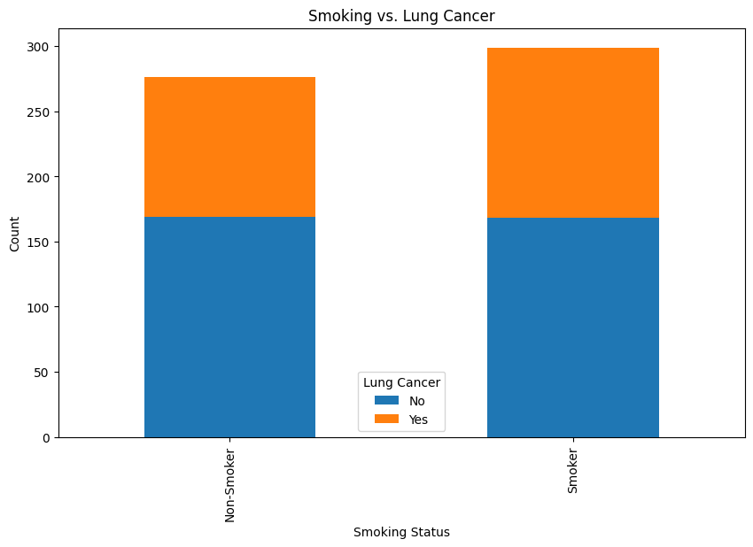

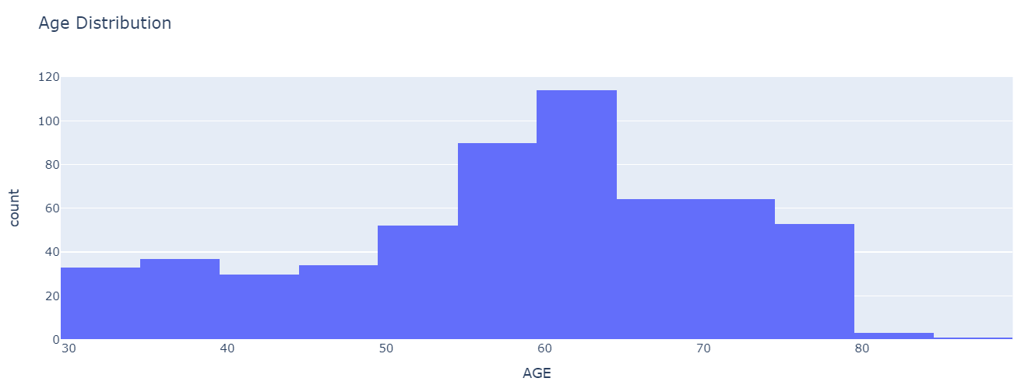**Histogram: Age Distribution**

**SunBurst Chart : Gender and Smoking Status w.r.t Lung Cancer**

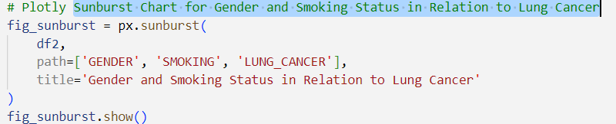 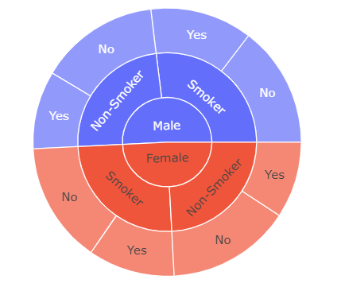

**Predictions:**

• For prediction, we formatted the data based on various patient attributes such as demographic information, lifestyle factors, and medical history to predict whether a patient is likely to develop **lung cancer**.  
• For all the experiments, we used an 80:20 training and testing ratio to split the dataset.

**i. XGBoost   
ii. Gradient Boosting Classifier  
iii. Random Forest Classifier**

**iv. Naive Bayes Classifiers**

• Testing metrics: We used **accuracy**, **precision**, **recall**, **F1-score**, and **ROC-AUC** to evaluate the performance of the models.  
• We also visualized the predicted and actual outcomes using **confusion matrices** and **ROC curves** to compare the model's performance.  
• We conducted two types of training: one with the complete dataset and another by training the model on a specific subset of data (e.g., based on patient demographics or symptom history).  
• We reported the **mean** and **standard deviation** of the evaluation metrics, with the first set representing the ground truth and the second set representing the model predictions**.**

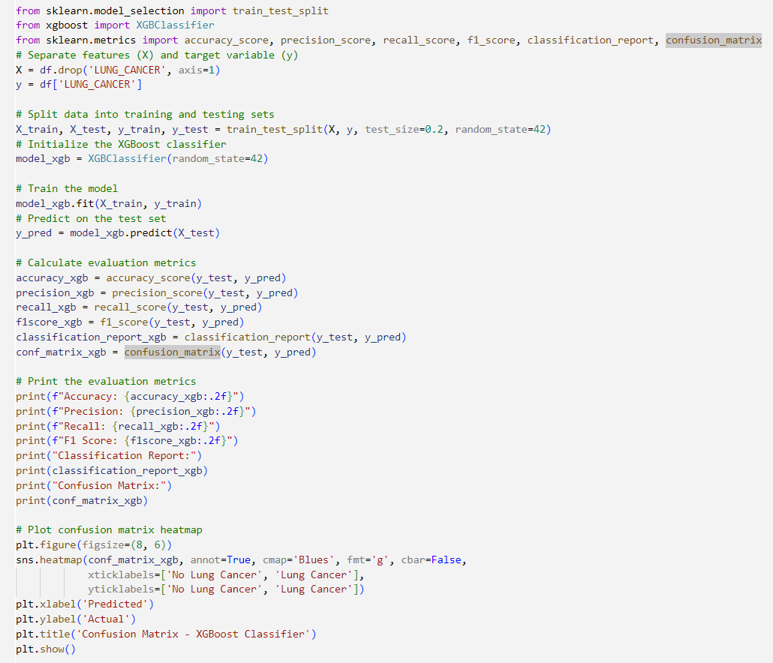**XGBoost :**

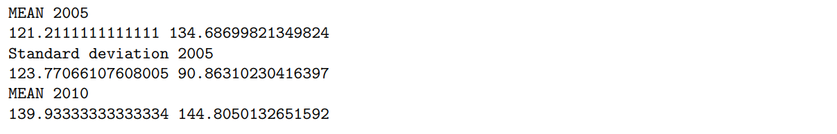

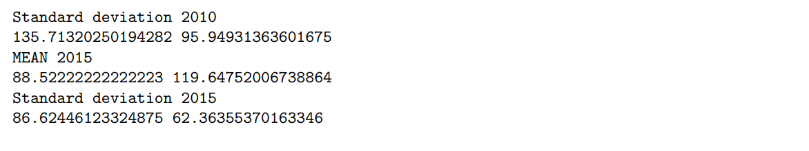

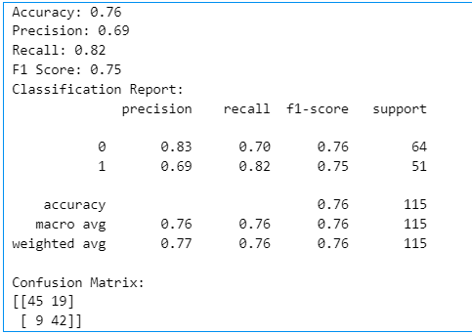

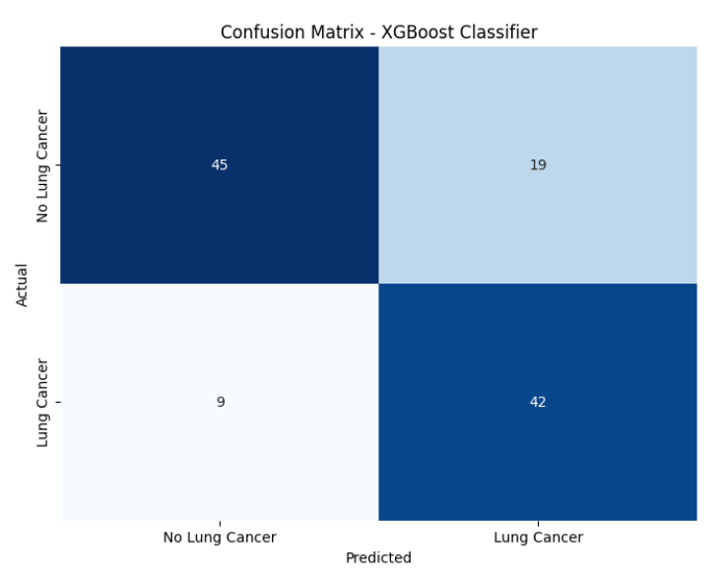

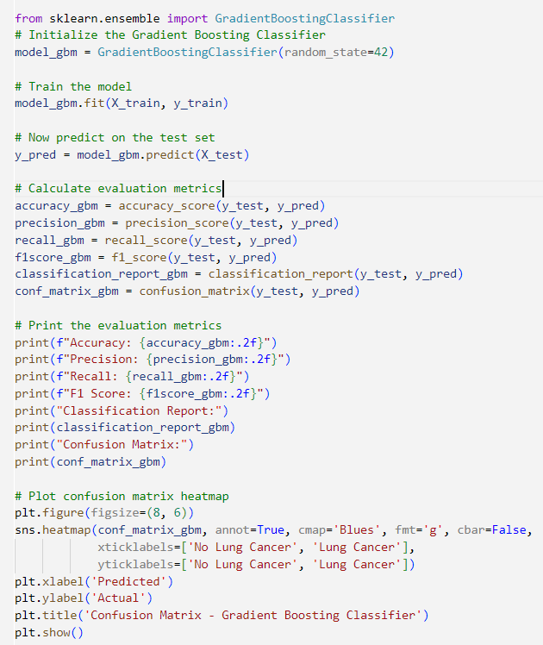**Gradient Boosting Classifier :**

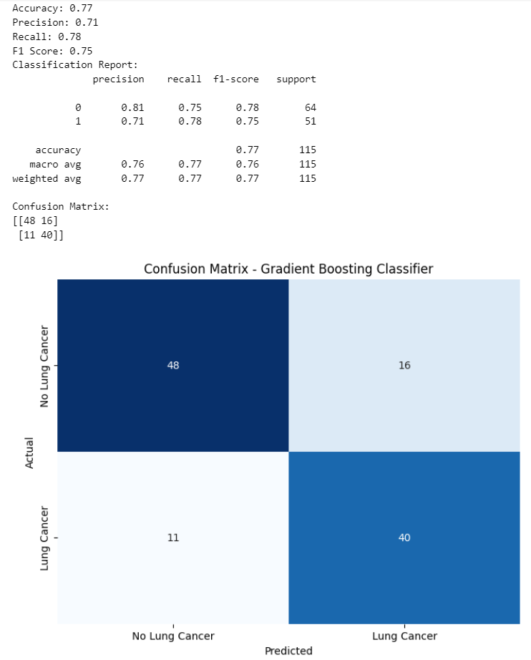

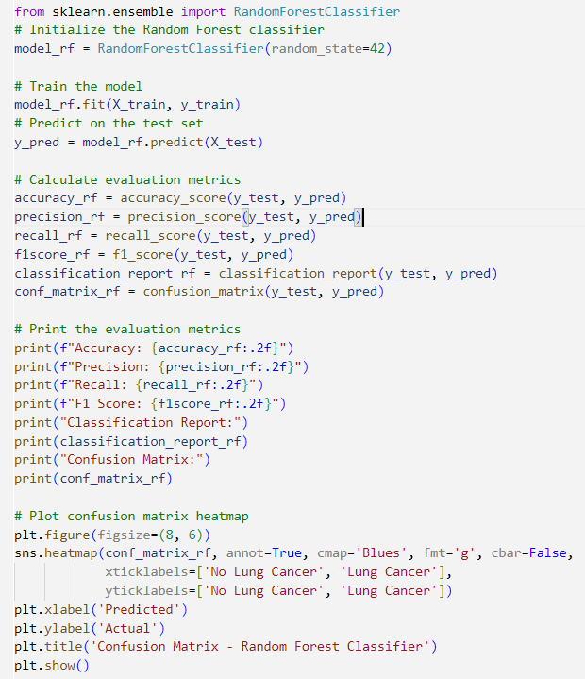**Random Forest Classifier :**

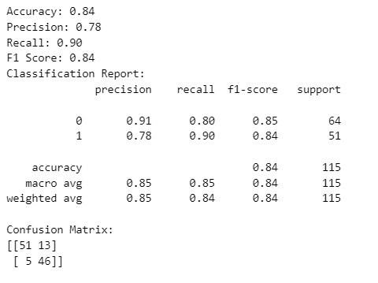

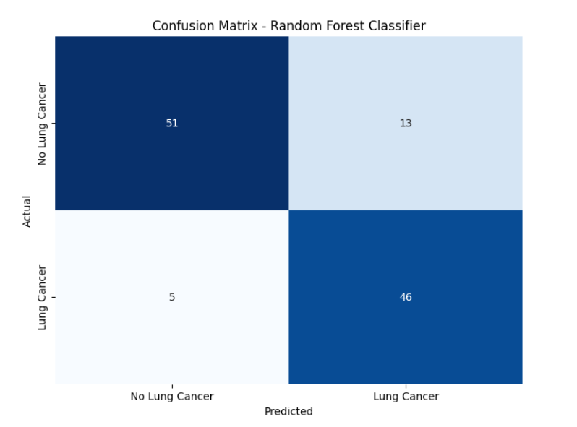

**Prediction Observations:**

**Training on complete dataset-**

|  |  |
| --- | --- |
| **Algorithm** | **ACCURACY** |
| XGBoost | 76 |
| Gradient Boosting | 77 |
| Random Forest | 84 |
| Gaussian NB | 70 |

**Feature Importance of RANDOM FOREST :**

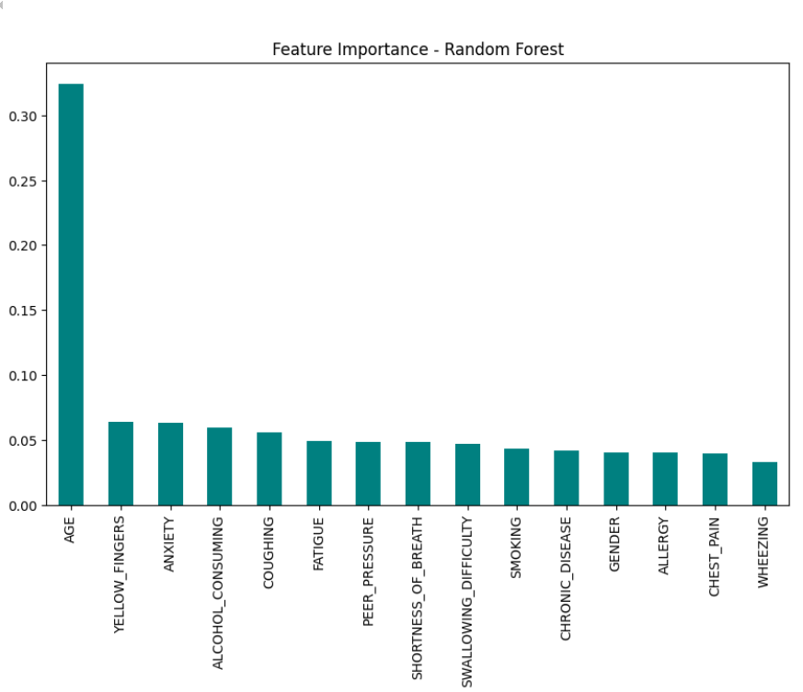

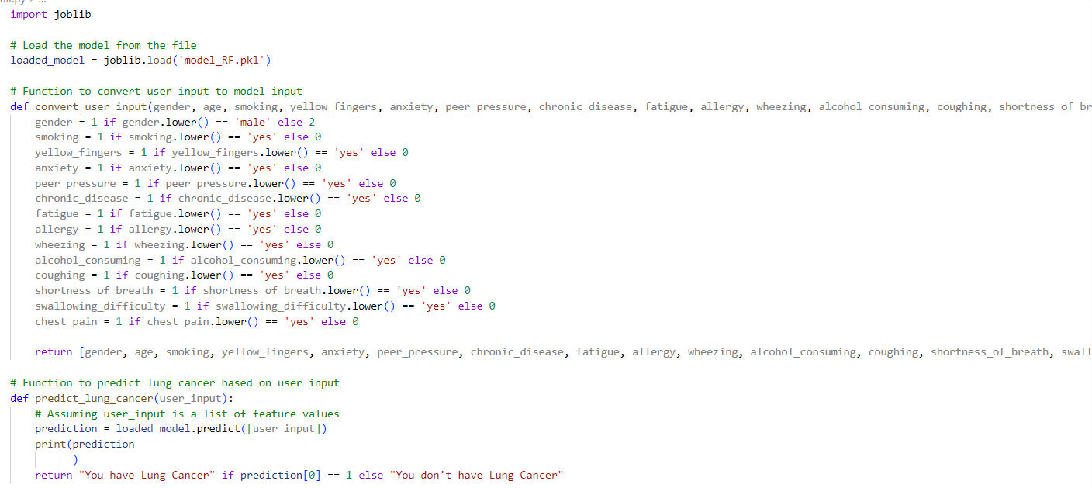**Model Implementation :**

**Technologies:**

• Programming language : Python

• Libraries : numpy, pandas, matplotlib, seaborn, keras, scipy, sklearn

**Web App:**

The web app is built with **Streamlit**, a powerful framework for developing interactive web applications, ensuring an easy-to-use interface and real-time predictions. The model is trained on the Indian Meteorological Department's (IMD) Yearly Gridded Rainfall dataset, offering a comprehensive analysis of the model’s prediction accuracy and statistics for each year.

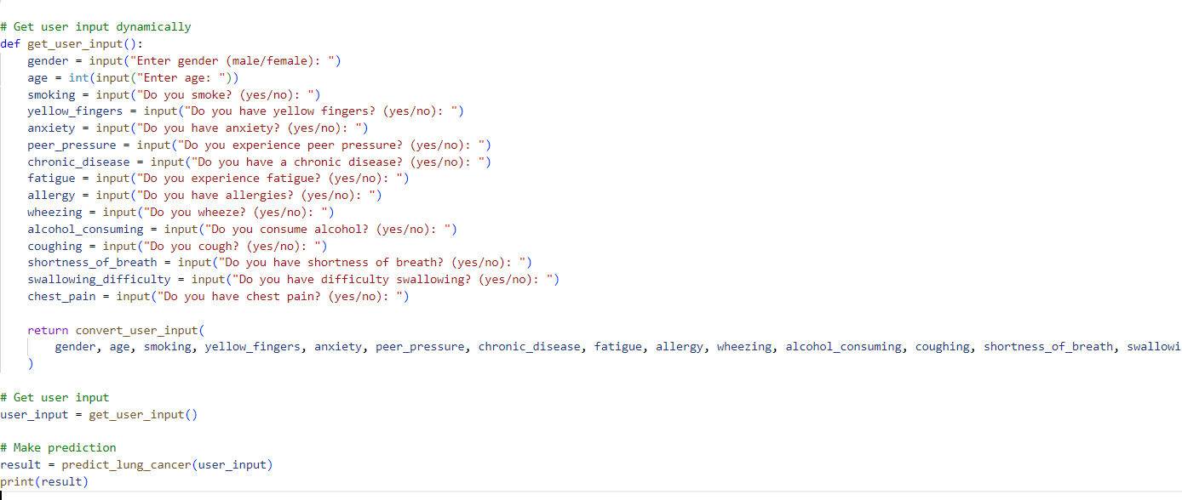

**OUTPUT :**

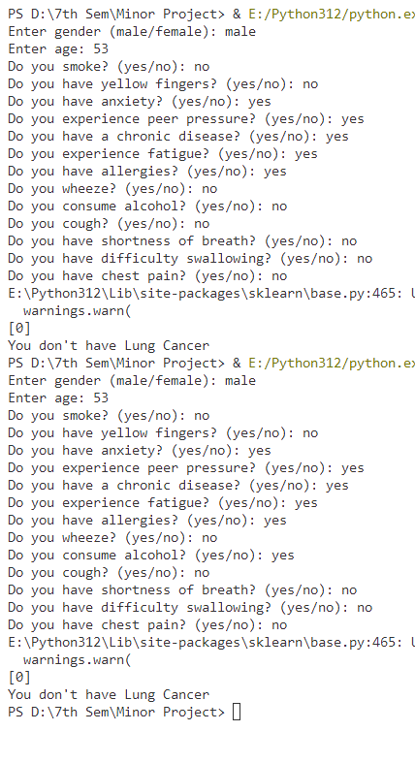



**Web App:**

The web app is built with **Streamlit**, a powerful framework for developing interactive web applications, ensuring an easy-to-use interface and real-time predictions. The model is trained on the Indian Meteorological Department's (IMD) Yearly Gridded Rainfall dataset, offering a comprehensive analysis of the model’s prediction accuracy and statistics for each year.

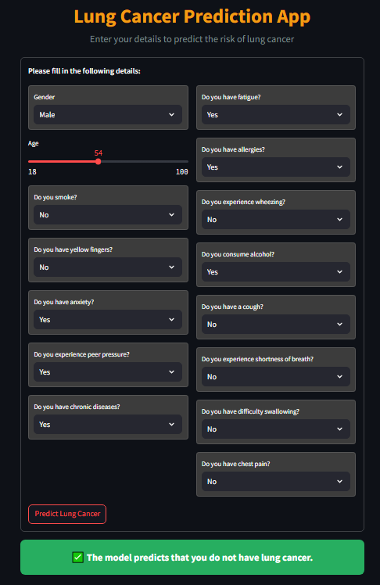

**Future Enhancements**

To further enhance the **Lung Cancer Detection using Machine Learning** project and improve its diagnostic capabilities, several key improvements are planned for future development:

1. **Real-Time Data Integration:** Integrating real-time data from medical databases or health monitoring devices will allow the model to provide up-to-date predictions. This will enable more accurate and timely cancer detection, aiding in early diagnosis and better treatment planning.
2. **Advanced Model Tuning:** Further hyperparameter tuning and the exploration of advanced machine learning techniques, such as **ensemble learning** (e.g., **Random Forests**, **Gradient Boosting Machines**) and **deep learning** (e.g., **Convolutional Neural Networks**, **Recurrent Neural Networks**), will be employed to improve prediction accuracy and the robustness of the model.
3. **Incorporation of Additional Clinical Factors:** Including more clinical and genetic factors (e.g., **family history**, **genetic markers**, **previous medical conditions**) in the model will offer a more comprehensive and personalized prediction, potentially improving the accuracy of lung cancer detection.
4. **Multimodal Data Integration:** Developing models that combine data from various sources such as **X-rays**, **CT scans**, **biopsy reports**, and **patient history** will enhance the precision of diagnosis. This approach would address different stages and types of lung cancer, improving the model's adaptability.
5. **Visualization Enhancements:** Implementing interactive visualizations like **heatmaps**, **decision trees**, and **ROC curves** will aid healthcare professionals in interpreting model predictions. These visual enhancements can improve the decision-making process, making the predictions more interpretable and actionable.
6. **Mobile and Web Interface:** Developing a user-friendly **mobile and web interface** will make the lung cancer prediction tool accessible to a wider range of users, including healthcare providers, patients, and researchers. This will increase the model's usability and impact, enabling users to access predictions and guidance easily.

These enhancements aim to make the **Lung Cancer Detection** model more **accurate**, **robust**, and **accessible**, contributing to the advancement of **early cancer diagnosis** and **personalized healthcare**.

**Conclusion**

In conclusion, the **Lung Cancer Detection using Machine Learning** project represents a significant advancement in applying machine learning techniques for early cancer detection. By utilizing clinical and lifestyle data, the project establishes a strong foundation for predicting the likelihood of lung cancer. The processes implemented, including **data preprocessing**, **exploratory data analysis**, and **model selection**, have contributed to building an initial predictive model.

While the current implementation focuses on machine learning techniques such as **Logistic Regression**, **Random Forest**, and **Gradient Boosting**, the project is poised for further enhancement. Planned improvements, such as incorporating **real-time patient data**, refining the model with **additional clinical factors** (e.g., genetic information), and improving **visualization techniques**, will enhance the model’s **accuracy** and **usability**.

As the project progresses, these future enhancements will ensure that the **lung cancer detection** model becomes a valuable tool for healthcare professionals, offering **early diagnosis** and **personalized treatment plans**. The ultimate goal is to provide **accurate**, **real-time insights** into lung cancer risk, contributing to better-informed decisions in **cancer prevention** and **treatment**.

**References:**

1. Pandas Documentation: https://pandas.pydata.org/docs/
2. NumPy Documentation: https://numpy.org/doc/
3. Scikit-learn Documentation: https://scikit-learn.org/stable/
4. Matplotlib Documentation: https://matplotlib.org/stable/contents.html
5. https://www.cancer.org/cancer/types/lung-cancer/about/key-statistics.html): https://www.americanSociety welfare.gov.in/
6. Seaborn Documentation: https://seaborn.pydata.org/